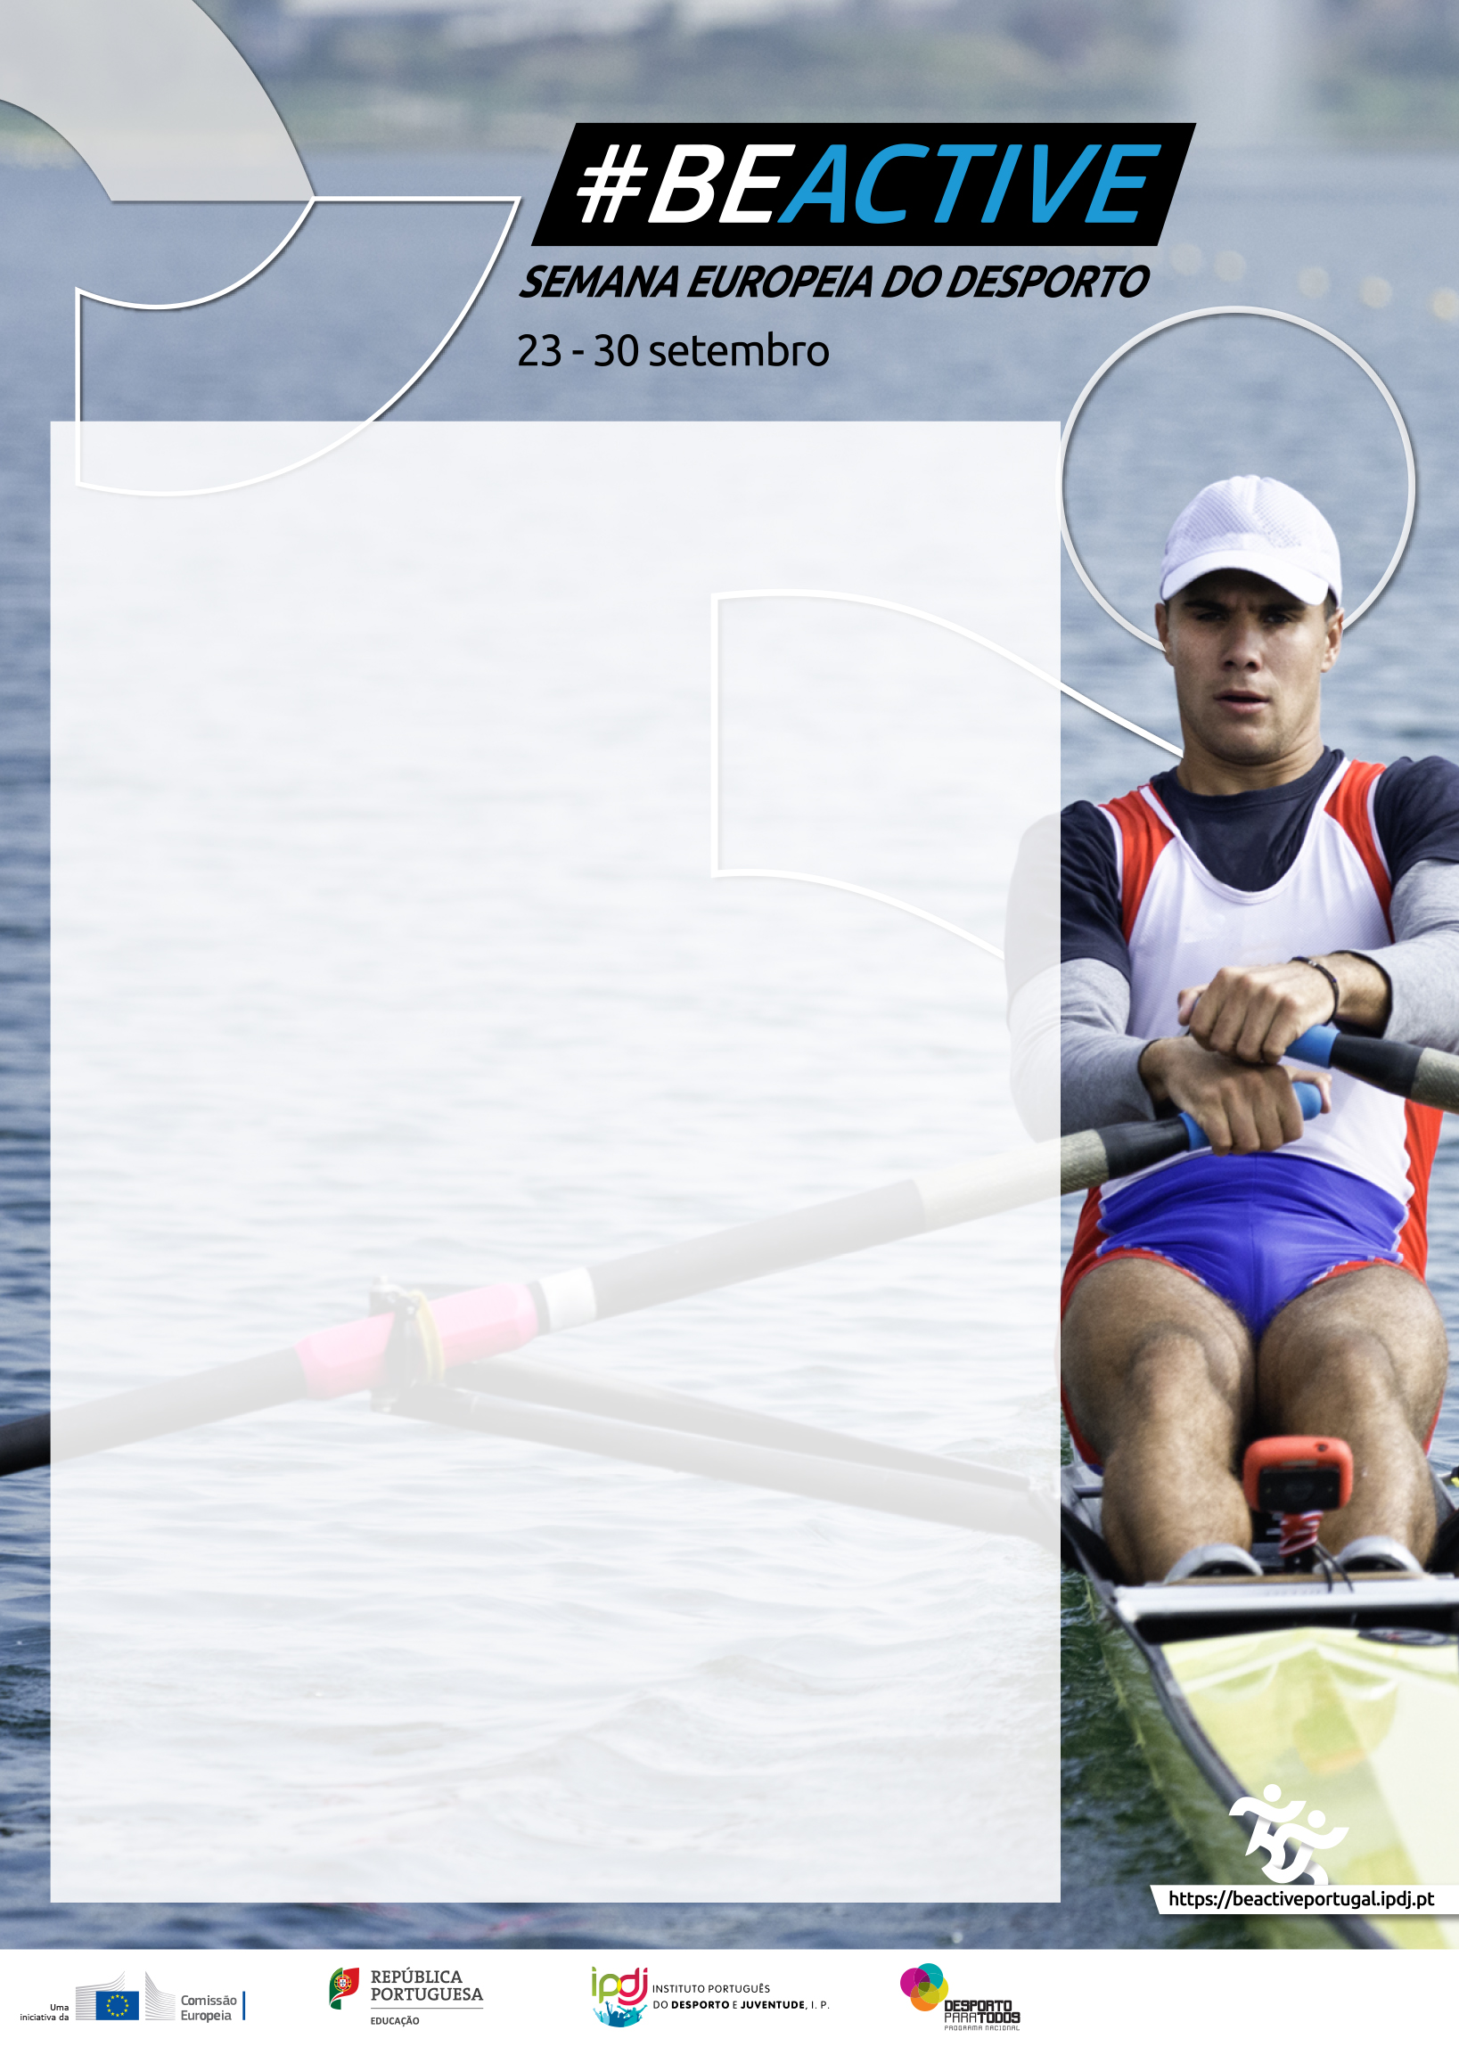

**COLOCAR TEXTO/PROGRAMA**

locar textos nw-SLKHDLksdlkDLslakdLSLashdlLDSAkslahd sALHDlsld -lAKHD. ,DlaskdLAKSHDladL nbadsflaal nw-SLKHDLksdlkDLs lakdLSLashdlLDSAkslahd sALHD-llsld- ,DlaskdLAKSHDladLasNansnN

Colocar textos nw-SLKHDLksdlkDLslakdLSLashdlLDSAkslahd sALHD-llsld-lAKHD. ,DlaskdLAKSHDladL KGKKKFKFK<

Colocar textos nw-SLKHDLksdlkDLslakdLSLashdlLDSAkslahd sA-llsld-lAKHD. ,DlaskdLAKSHDladLHFH HFHF jjk

Colocar textos nw-SLKHDLksdlkDLslakdLSLashdlLDSAkslahd

-lAKHD. ,DlaskdLAKSHDladLjjjjjjjg gggggg

Colocar textos nw-SLKHDLksdlkDLslakdLSLashdlLDSAkslahd s

-llsld-lAKHD. ,DlaskdLAKSHDladL jjhgsyusnnn

locar textos nw-SLKHDLksdlkDLslakdLSLashdlLDSAkslahd

lAKHD. ,DlaskdLAKSHDladL nbadsflaal.

Colocar textos nw-SLKHDLksdlkahd sALHD-llsld-lAKHD. ,DlaskdLAKSHDladLasNansnN

Colocar textos nw-SLKHDLksdlkDLslakdL -llsld-lAKHD. ,DlaskdLAKSHDladL

Colocar textos nw-SLKHDLksdlkDLslak -llsld-lAKHD. ,DlaskdLAKSHDladLjjjj

Colocar textos nw-SLKHDLksdlkDLslakdLSLashdlLDS

Logos -Parceiros